PROJECT-44
AI Review Analyzer
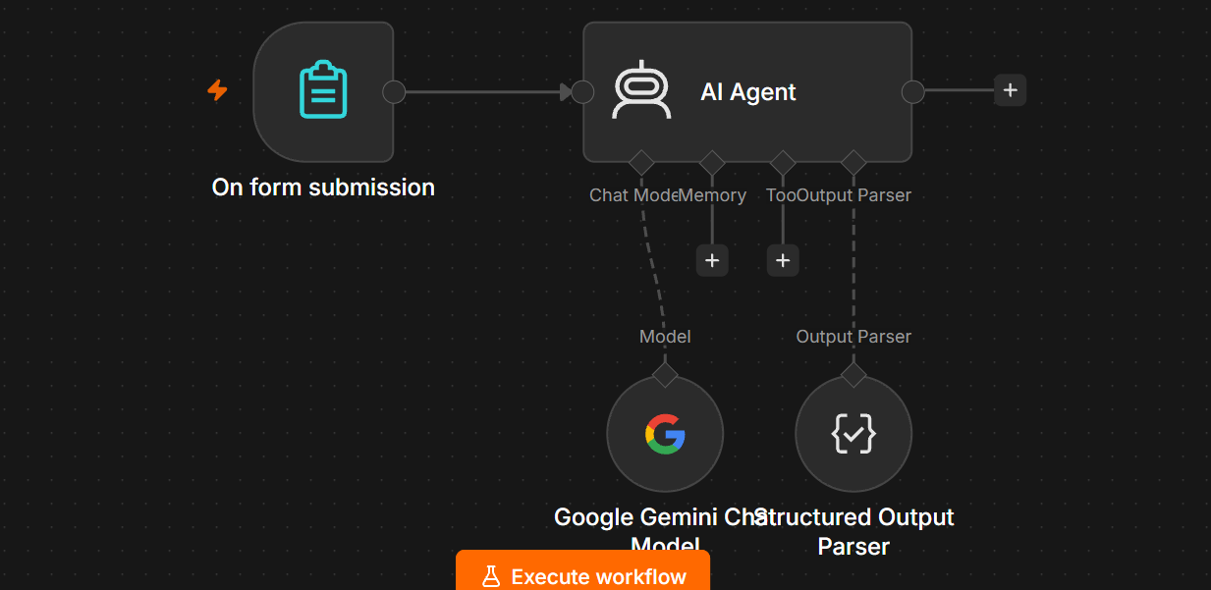
1. Project Overview
The AI Review Analyzer automatically analyzes customer reviews using an n8n AI Agent + Google Gemini.
It can identify:
- ⭐ Sentiment
- ⭐ Rating
- ⭐ Review summary
- ⭐ Key points
- ⭐ Positive aspects
- ⭐ Negative aspects
- ⭐ Customer issues
- ⭐ Priority
- ⭐ Recommended action
Basic Workflow
On Form Submission
↓
AI Agent
↓
Google Gemini
↓
Structured Output

2. Objective
The purpose of this project is to automatically convert an unstructured customer review into useful structured information.
For example:
Customer submits:
The product quality is excellent and delivery was fast,
but the packaging was damaged when I received it.
AI returns:
{
"sentiment": "Mixed",
"summary": "The customer is satisfied with product quality and delivery speed but is unhappy with damaged packaging.",
"positive_points": [
"Excellent product quality",
"Fast delivery"
],
"negative_points": [
"Damaged packaging"
],
"issues": [
"Packaging damage"
],
"priority": "Medium",
"recommendation": "Improve packaging and handling during delivery."
}

3. Nodes Required
For this project, use only these nodes:
Main workflow
- On Form Submission
- AI Agent
AI Agent sub-node
- Google Gemini Chat Model
- Structured Output Parser
You do not need:
- Vector Store
- Data Loader
- Text Splitter
- Embeddings
- Memory
for this basic project.

4. Node 1 — On Form Submission
Add:
On Form Submission
Create these fields.
Field 1 — Customer Name
Type:
Text
Field name:
Customer Name

Field 2 — Product
Type:
Text
Field name:
Product

Field 3 — Rating
Type:
Number
Field name:
Rating
Set the rating between:
1 – 5

Field 4 — Review
Type:
Text Area
Field name:
Review
Use Text Area, because customers may enter long reviews.

5. Example Form
Your form should contain:
Customer Name:
John

Product:
Laptop

Rating:
3

Review:
The laptop performance is very good and delivery was fast,
but the battery backup is poor and the packaging was damaged.

6. Connect the Form to AI Agent
Connect:
On Form Submission
↓
AI Agent
The normal green connection should be used here.

7. Node 2 — AI Agent
Open your AI Agent.
For:
Source for Prompt
Select:
Define below
Then put this in Prompt (User Message):
Analyze the following customer review.

Customer Name:
{{ $json['Customer Name'] }}

Product:
{{ $json['Product'] }}

Rating:
{{ $json['Rating'] }}

Review:
{{ $json['Review'] }}

Analyze the review and provide:

1. Customer name
2. Product
3. Rating
4. Sentiment
5. Review summary
6. Positive points
7. Negative points
8. Issues identified
9. Priority
10. Recommended action

8. System Message
Use this:
You are an AI Review Analyzer.

Your job is to analyze customer reviews accurately and convert
them into useful structured information.

IMPORTANT RULES:

1. Analyze only the information provided in the review.
2. Do not invent facts.
3. Do not change the customer's meaning.
4. Identify the overall sentiment.
5. Summarize the review clearly.
6. Identify positive points.
7. Identify negative points.
8. Identify specific issues mentioned by the customer.
9. Assign a priority based on the seriousness of the issue.
10. Provide a practical recommended action.
11. Use simple and professional language.
12. Return the information using the required structured output format.

Sentiment must be one of:

Positive
Negative
Neutral
Mixed

Priority must be one of:

Low
Medium
High

9. Node 3 — Google Gemini Chat Model
Add:
Google Gemini Chat Model
Connect it to:
AI Agent
↓
Chat Model
It should look like:
Google Gemini
│
▼
On Form → AI Agent
Use the Gemini credential that is already working in your previous AI projects.

10. Node 4 — Structured Output Parser
Inside the AI Agent, enable:
Require Specific Output Format
Then add:
Structured Output Parser
Connect:
Structured Output Parser
↓
Output Parser
↑
AI Agent

11. Structured Output Format
Use this example:
{
"customer_name": "John",
"product": "Laptop",
"rating": 3,
"sentiment": "Mixed",
"summary": "The customer is satisfied with the laptop performance and delivery speed but is unhappy with battery backup and damaged packaging.",
"positive_points": [
"Good laptop performance",
"Fast delivery"
],
"negative_points": [
"Poor battery backup",
"Damaged packaging"
],
"issues": [
"Battery performance",
"Packaging damage"
],
"priority": "Medium",
"recommended_action": "Improve battery performance and packaging quality."
}

12. Final Workflow Structure
Your canvas should look approximately like this:
┌───────────────────────┐
│ On Form Submission │
│ │
│ Customer Name │
│ Product │
│ Rating │
│ Review │
└───────────┬───────────┘
│
▼
┌──────────────┐
│ AI Agent │
└──────┬───────┘
│
▼
Structured Output
Parser
And underneath the AI Agent:
Google Gemini Chat Model
│
▼
AI Agent

13. Test Question / Review
Use this first:
Customer Name:
John

Product:
Laptop

Rating:
3

Review:
The laptop performance is excellent and delivery was very fast,
but the battery backup is poor and the packaging was damaged.
Then click:
Execute Workflow

14. Expected Output
You should get something similar to:
{
"customer_name": "John",
"product": "Laptop",
"rating": 3,
"sentiment": "Mixed",
"summary": "The customer is happy with the laptop performance and delivery but is unhappy with the battery backup and damaged packaging.",
"positive_points": [
"Excellent performance",
"Fast delivery"
],
"negative_points": [
"Poor battery backup",
"Damaged packaging"
],
"issues": [
"Poor battery backup",
"Packaging damage"
],
"priority": "Medium",
"recommended_action": "Improve battery performance and packaging quality."
}

15. Sentiment Logic
The AI should classify reviews into four categories.
Positive
I absolutely love this product.
The quality is excellent.
Output:
Positive
Negative
The product stopped working after two days.
Customer support did not help.
Output:
Negative
Neutral
The product arrived yesterday.
It is black and has 256GB storage.
Output:
Neutral
Mixed
The product quality is excellent,
but delivery was very late.
Output:
Mixed

16. Priority Logic
Low
Minor complaint or general feedback.
The color was slightly different than expected.
Medium
A meaningful problem that should be reviewed.
The packaging was damaged.
High
A serious issue requiring immediate attention.
The product arrived completely broken
and customer support refused to help.

17. Example 2 — Positive Review
Submit:
Customer Name:
Sarah

Product:
Headphones

Rating:
5

Review:
Excellent headphones. The sound quality is amazing,
the battery lasts a long time, and delivery was very fast.
Expected:
{
"sentiment": "Positive",
"priority": "Low"
}

18. Example 3 — Negative Review
Submit:
Customer Name:
Mike

Product:
Phone

Rating:
1

Review:
The phone arrived damaged. The screen was cracked
and customer support has not responded to my messages.
Expected:
{
"sentiment": "Negative",
"priority": "High"
}

19. Example 4 — Mixed Review
Submit:
Customer Name:
David

Product:
Monitor

Rating:
3

Review:
The monitor has excellent picture quality and looks great,
but delivery was late and the stand was damaged.
Expected:
{
"sentiment": "Mixed",
"priority": "Medium"
}

20. What You Learn From This Project
This project teaches you:
- n8n Forms
- AI Agent
- Google Gemini
- Dynamic expressions
- Prompt engineering
- Sentiment analysis
- Text summarization
- Information extraction
- AI classification
- Structured JSON output
- Output Parser

21. Optional Next Level
Once the basic workflow works, you can extend it:
Form
↓
AI Review Analyzer
↓
IF
↓
High Priority?
├── YES → Email/Slack → Support Team
│
└── NO → Google Sheets
You could also create a review dashboard containing:
Total Reviews
↓
Positive Reviews
Negative Reviews
Neutral Reviews
Mixed Reviews
↓
Average Rating
↓
Top Customer Issues
Final architecture
On Form Submission
↓
AI Agent
↙ ↘
Gemini Output Parser
↓
Structured Review
Analysis
This is the simplest correct version to build first. Once this executes successfully, add Google Sheets or email automation rather than adding extra AI/RAG nodes.

